Mockito Hands-On Exercises

# Exercise 1: Mocking and Stubbing

Scenario:

You need to test a service that depends on an external API. Use Mockito to mock the external API and stub its methods.

Steps:

1. Create a mock object for the external API.
2. Stub the methods to return predefined values.
3. Write a test case that uses the mock object.

Solution Code:

import static org.mockito.Mockito.*; import org.junit.jupiter.api.Test; import org.mockito.Mockito;

public class MyServiceTest { @Test

public void testExternalApi() {

ExternalApi mockApi = Mockito.mock(ExternalApi.class); when(mockApi.getData()).thenReturn("Mock Data"); MyService service = new MyService(mockApi);

String result = service.fetchData(); assertEquals("Mock Data", result);

}

}

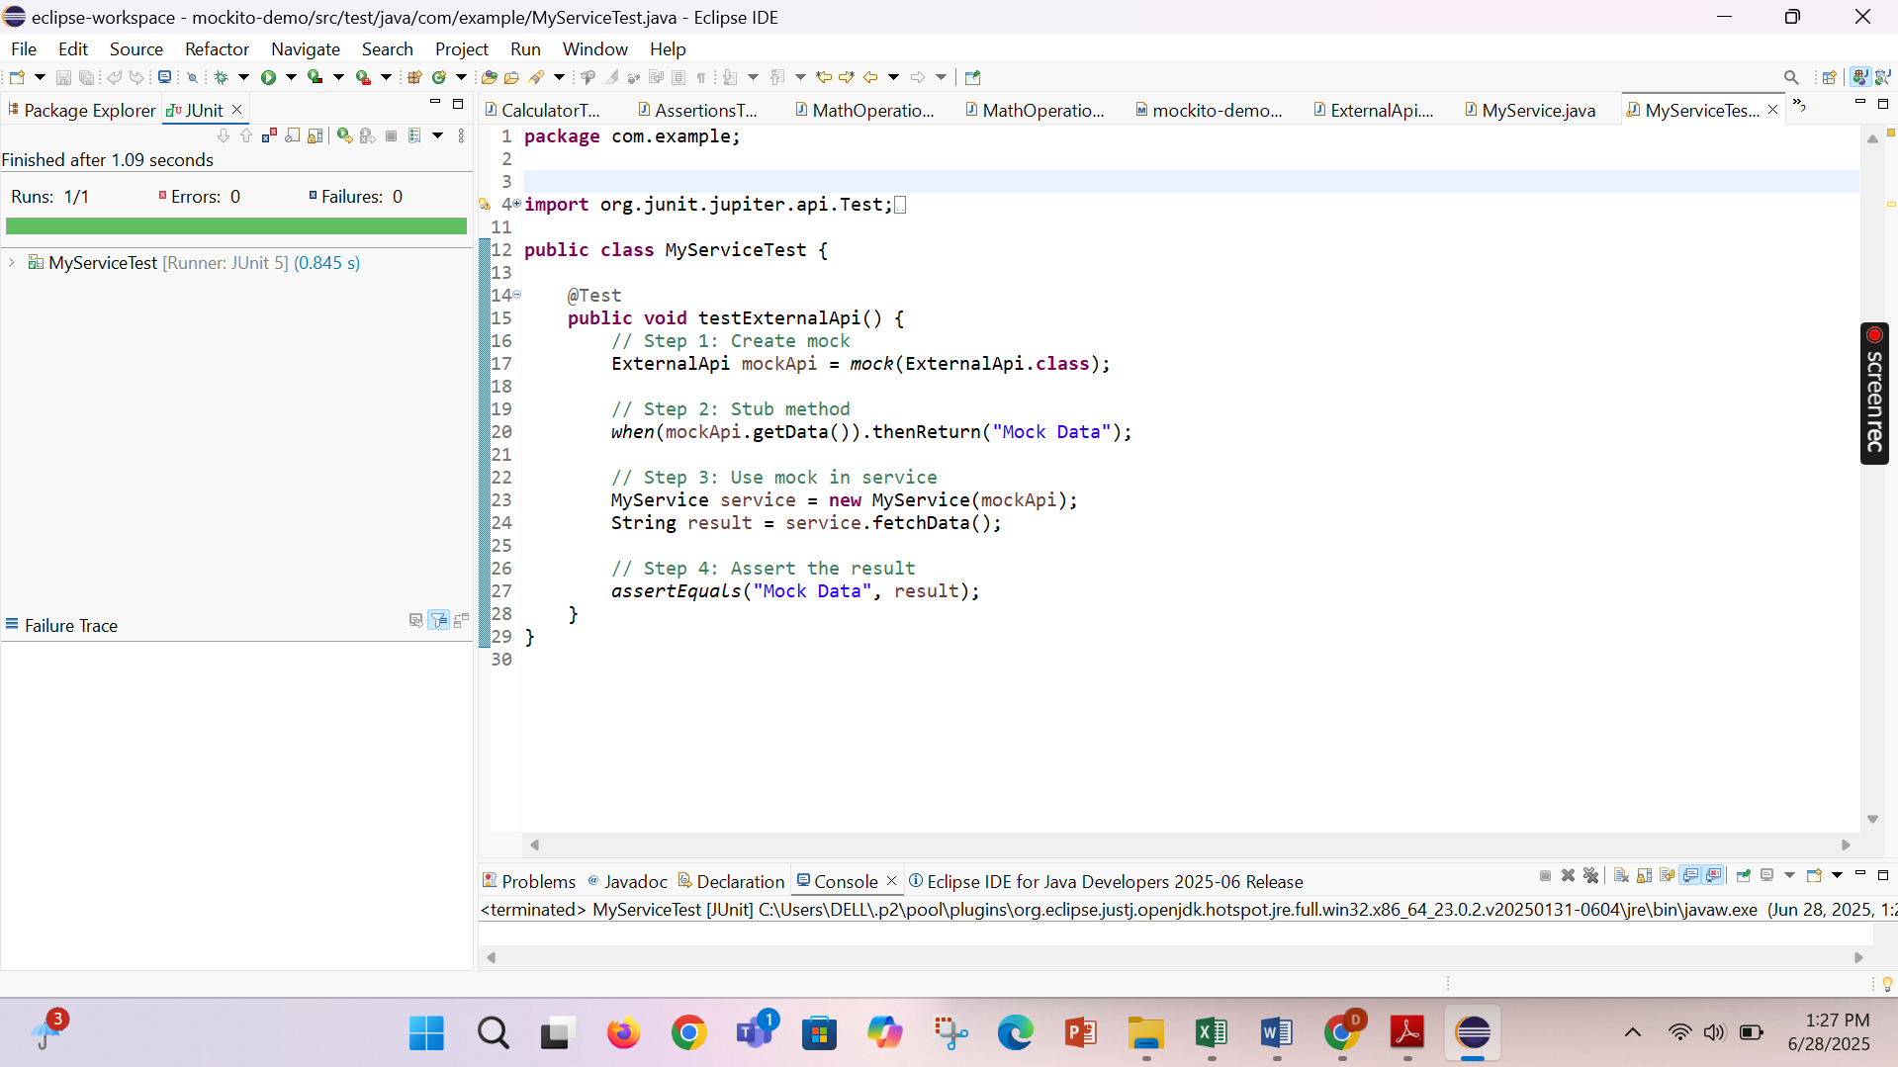

# Exercise 2: Verifying Interactions

Scenario:

You need to ensure that a method is called with specific arguments.

Steps:

1. Create a mock object.
2. Call the method with specific arguments.
3. Verify the interaction.

Solution Code:

import static org.mockito.Mockito.*;

import org.junit.jupiter.api.Test; import org.mockito.Mockito;

public class MyServiceTest { @Test

public void testVerifyInteraction() {

ExternalApi mockApi = Mockito.mock(ExternalApi.class); MyService service = new MyService(mockApi); service.fetchData();

verify(mockApi).getData();

}

}

